**CREATE NODE – RED SERVICE**

|  |  |
| --- | --- |
| DATE | 14-Nov-2022 |
| TEAM ID | PNT2022TMID43101 |
| PROJECT NAME | IOT Based Smart Crop Protection System for Agriculture |

**Step 1 :** Install node.js

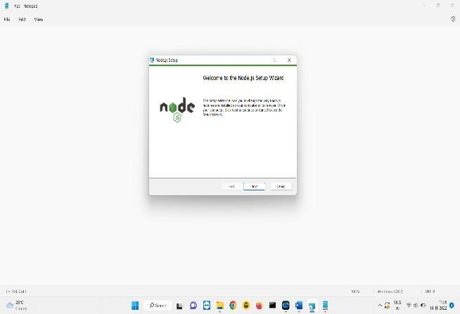

**Step 2 :**Next open command terminal

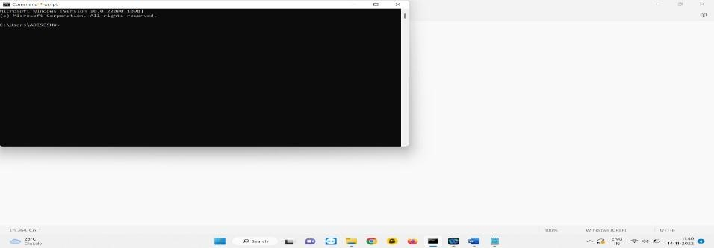

**STEP 3** : Type "npm install -g —unsafe-perm node-red" to download the node-red local service to your computer.

**STEP 4 :** Following installation, we must verify the node-red service for that type.

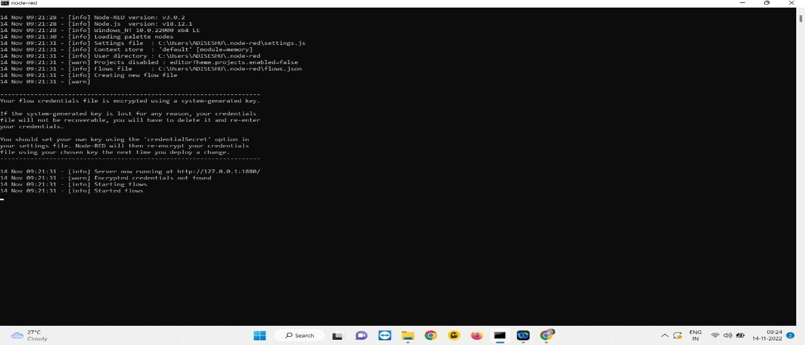

**STEP 5 :** The local node-red service is accessible at "http:// 127.0.0.1:1880," as this URL indicates.

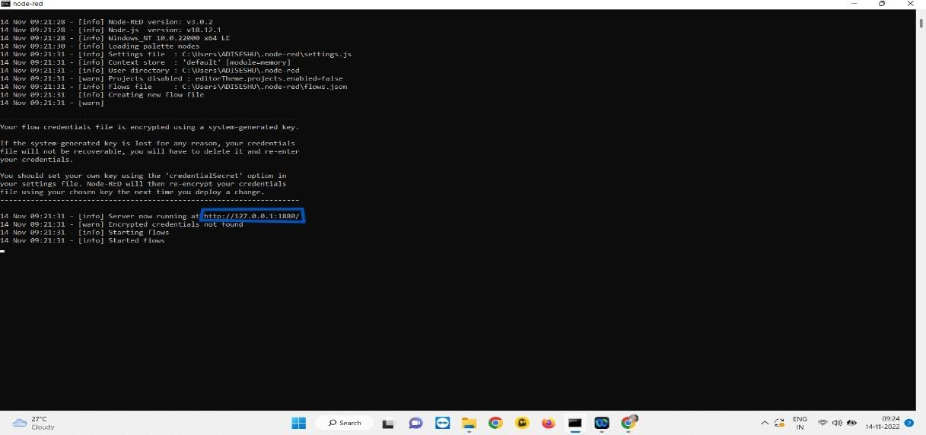

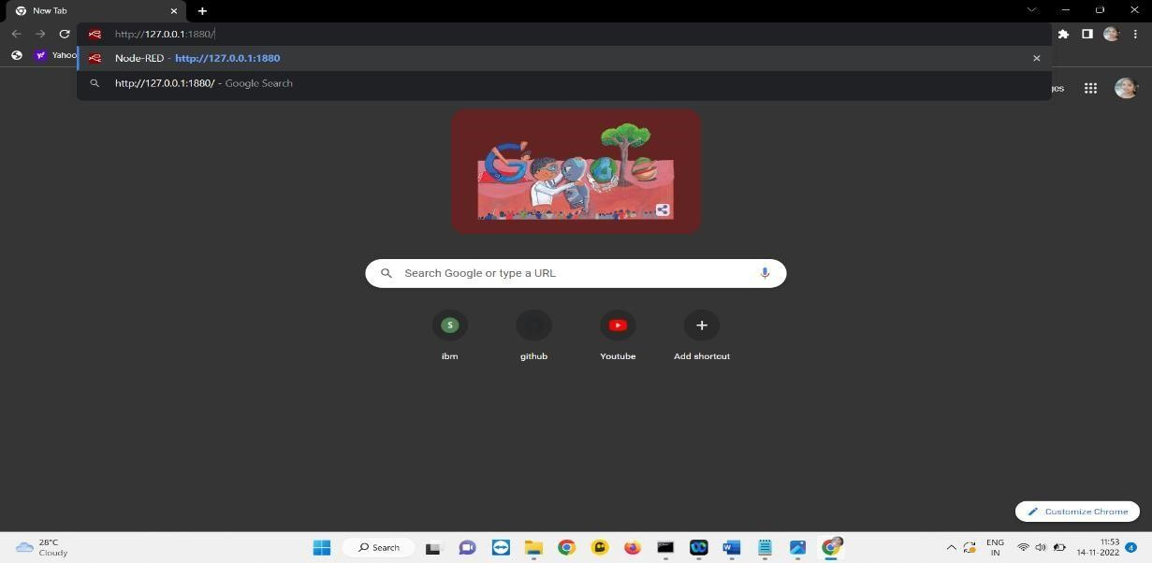

**STEP 6 :** Node-Red will then start up.

